Harry Phillips Postcards

JP1. Phillips Full Frame Series  Ph, Pu & Pr Harry Phillips  F Photograph fills whole card with title and Phillips imprint both superimposed.  JP1.1 The Willows/Nettle Cave/Jenolan V Simple Back  JP1.2 Broken Column/Lucas Cave/Jenolan V Empire  JP1.3 Devil’s Coach House and Bridge Three Sisters  JP1.4 Crystal Fountain/Lucas Cave/Jenolan V ? | 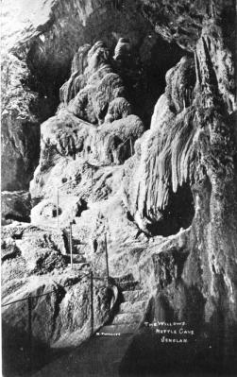

JP2. PHILLIPS SERIES 2

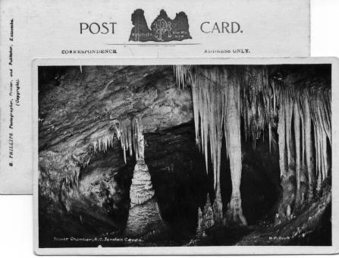
Ph & Pu Harry Phillips
F Photograph with white margin all round, title superimposed on view; back printed
with 'Three Sisters' emblem (see illustration).

Four variations:
Pr H. Phillips
- Back printed in black JP2A
- Back printed in blue JP2B
Pr "Echo" Print, Katoomba for H. Phillips, Photographer

JP2A.1 Steps connecting/Nettle & Arch Caves/Jenolan Caves V
JP2A.2 Crystal Palace, R.I.C. Jenolan Caves V
JP2A.3 The Minarett,(sic) R.C. Jenolan Caves V
JP2A.4 Grand Column, R.C. Jenolan Caves V
JP2A.5 Giant Shawl, R.C., Jenolan Caves V
JP2A.6 Grand Entrance Caves House/Jenolan Caves. V
JP2A.7 Entrance Devil’s Coach/House, Jenolan Caves V
JP2A.8 The Proscenium, L.C./Jenolan Caves V
JP2A.9 Tower Chamber, R.C., Jenolan Caves H
JP2A.10 Mafeking Cave, Jenolan Caves H
JP2A.11 Nellie’s Grotto, R.I.C. Jenolan Caves H
JP2A.12 Devil’s Coach House & Bridge/from Lucas Entrance, Jenolan Caves V
JP2A.13 Shawls, R.I.C., V

JP2B.1 Carlotta & Grand Arches,/Lake Jenolan V
JP2B.2 Carlotta Arch &/Jenolan Road V

JP2C.1 The Mystery Rt Imp V (Also has 'Jenolan Caves' neatly
printed in lower margin ; format is otherwise as JP2A) [pm. 15 Nov 1909]
JP3.2 The Willows/Nettle Cave/Jenolan V (Also has ‘The Willows’ neatly
printed in lower margin ; format is otherwise as JP2A)

JP3. PHILLIPS SERIES 3 [n.l. 1918]

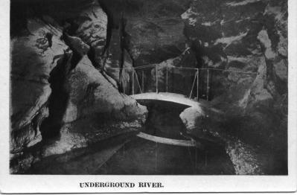

Ph, Pu & Pr Harry Phillips
Title printed bold caps with serifs on lower margin of card,
- View in B.& W. JP3A
- View in colour JP3B
Title in sans-serif caps & lower case JP3C

JP3A.1 Tower Chamber, River Cave H
JP3A.2 Aladdin Cave H
JP3A.3 Underground River H
JP3A.4 The Proscenium, Lucas Cave V
JP3A.5 Alabaster Column V
JP3A.6 The Grand Column, River Cave V
JP3A.7 The Giant Shawl, River Cave V
JP3A.8 Gem of the South V [ms.15 Jan.1918]
JP3A.9 Gem of the South V (another view)
JP3A.10 Near Grand Arch, Jenolan V
JP3A.11 Grand Stalactites, Right Imperial Cave V [pm.29 May 1919]
JP3A.12 Broken Column, Lucas Cave V (distant view)
JP3A.13 The Mystery, Left Imperial V
JP3A.14 The Willows, Nettle Cave V [ms.6 Apr.1918]
JP3A.15 Mons Meg Chamber, River Cave V
JP3A.16 Nellie's Grotto, Right Imperial H [ms. Easter 1918]
JP3A.17 Indian Chamber, Orient Cave V
JP3A.18 Gem of Jenolan V
JP3A.20 The Grand Arch, Jenolan V [ms.5 Apr.1918]
JP3A.21 Rock Wallabies, near Grand Arch H [ms.5 Apr.1918]
JP3A.22 The Minaret, River Cave V
JP3A.23 Punt on the Underground River H
JP3A.24 Proscenium, Lucas Cave H
JP3A.25 Broken Column, Lucas Cave V (close view; has title also superimposed on photograph)
JP3A.26 Carlotta Arch V
JP3A.27 Gem of the West, Right Imperial V
JP3A.28 Temple of Baal V
JP3A.29 Orient Cave V

JP3B.1 Near Grand Arch, Jenolan V [ms. 15 Dec 1915]

JP3C.1 Devil's Coach-house, Jenolan V [pm.2 May 1910]
Sender says, 'This is a very wonderful place, which I will explain all about when I see you. You can see the stalactites from the roof, and there are wallabies hopping about the rocks.”

JP4. PHILLIPS SERIES

Ph, Pu & Pr Harry Phillips
F Picture with white margin all round; title in lower margin using fine sans-serif caps; back has
fancy scroll design and map with slogan 'See Australia First.'; printed in B. & W.

JP4.1 The Willows, Nettle Cave, Jenolan Caves V (s.n.a. 45.14)
JP4.2 Giant Shawls, Mons Meg Branch of Lucas, Jenolan Caves V
JP4.3 Glimpse of Caves House and Kiosk, Jenolan Caves H
JP4.4 Preparing to leave Jenolan after afternoon inspection
V (shows many cars along road near Caves House)
JP4.5 Crystal Cities or Fortifications, Right Imperial, Jenolan Caves H
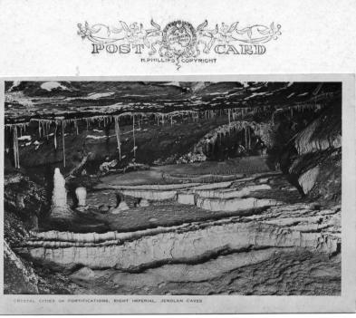

JP4.6 Looking East from Grand Arch, Jenolan Caves H
JP4.7 Carlotta Arch, Jenolan Caves V
JP4.8 Caves Road and Lake Jenolan, from Lucas Rocks V (s.n.a. 45.10)
JP4.9 Nellie's Grotto, Right Imperial, Jenolan Caves H (s.n.a. 45.16)
JP4.10 Northern Entrance to Devil's Coach House, Jenolan Caves V
JP4.11 Lot's Wife, Right Imperial, Jenolan Caves V
JP4.12 The Minaret, River Cave, Jenolan Caves V
JP4.13A Caves House, Jenolan Caves H
JP4.13B Caves House, Jenolan Caves H (coloured print)
JP4.14 Queen's Diamonds, Right Imperial, Jenolan Caves H
JP4.15 Temple of Baal, Lucas Cave, Jenolan Caves V
JP4.16 Angel's Wings, Orient Cave, Jenolan Caves V
JP4.17 A Glimpse of Caves House, Jenolan Caves V
JP4.18 The Proscenium, Lucas Cave, Jenolan Caves V
JP4.19 Coral Grotto, Right Imperial, Jenolan Caves V
JP4.20 Lucinda Cave, Left Imperial, Jenolan Caves V
JP4.21 Red and White Shawls, Orient Cave, Jenolan Caves V
JP4.22 Steps, River Branch, Orient Cave, Jenolan Caves V
JP4.23 Gem of the West, Right Imperial, Jenolan Caves V
JP4.24 Mafeking Cave, in Lucas, Jenolan Caves V
JP4.25 Grand Stalactites, Right Imperial, Jenolan Caves V
JP4.26 Grand Column, River Branch, Lucas, Jenolan Caves V
JP4.27 Measured Stalactite, Right Imperial, Jenolan Caves V
JP4.28 Gem of the South, Temple of Baal Branch, Lucas, Jenolan Caves V
JP4.29 Transparent Shawls, Right Imperial, Jenolan Caves V
JP4.30 Furze Bushes, River Branch, Lucas, Jenolan Caves V
JP4.31 Broken Column, Lucas Cave, Jenolan Caves V
JP4.32 Hospital Box, Skeleton Cave, Jenolan Caves H
[Depicts coins scattered in crystal basin - a common
practice in many show caves until recently.]
JP4.33 Refreshment Room, Kiosk and Post Office, Jenolan Caves H
JP4.34 Wallaby Cave, Jenolan Caves H
JP4.35 Tent Canopy, Lucas Cave, Jenolan Caves V
JP4.36 Bridge and Devil’s Coach House/from Entrance, Lucas Cave, Jenolan Caves V
JP4.37 Victoria Bower, Gem of Jenolan V
JP4.38 Steps connecting Nettle and Arch, Jenolan Caves V
JP4.39 Arch Cave, Jenolan Caves H
JP4.40 Crystal Palace, Right Imperial, Jenolan Caves V
JP4.41 Bone Cave in Lucas, Jenolan Caves V

JP5. PHILLIPS SERIES

Ph, Pu & Pr Harry Phillips

Picture is coloured half-tone print on “See Australia First” back
- Small size back imprint as JP4 JP5A
- Large size back imprint JP5B

JP5A.1 Caves House, Jenolan H
JP5A.2 No.104 Jenolan Caves Road, near Grand Arch V
[ms. November 1945
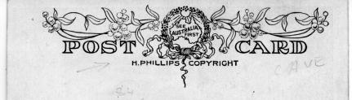
JP5B.1 Grand and Carlotta Arches, Jenolan Caves V
JP5B.2 Jenolan Caves Road, near Grand Arch V [pm. n.e.19JP3]

JP6. PHILLIPS GREETING CARD

Ph, Pu & Pr Harry Phillips
F Multi-image greeting card with small “See Australia First” back

JP6.1 Greetings from Jenolan Caves H | 